57th ANNUAL GENERAL ASSEMBLY

Post-AGA Tour (New Zealand, North Island)

15–19 October 2026

Hosted by
WORLD AIRLINES CLUBS ASSOCIATION

--------------------------------------------------------------------------------
--------------------------------------------------------------------------------

INTRODUCTION TO NEW ZEALAND

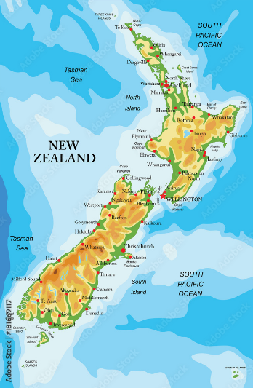
New Zealand is an island country in the southwestern Pacific Ocean. It consists of two main landmasses—the North Island (Te Ika-a-Māui) and the South Island (Te Waipounamu)—and over 600 smaller islands. The Māori name for New Zealand “Aotearoa” is translated as “land of the long white cloud” which refers to the cloud formations which are believed to have helped early Polynesian navigators find the country.

The month of October is springtime in New Zealand and the North Island offers unforgettable experiences of lively cities with a large helping of culture and history for a truly diverse experience. It is one of the most unique destinations on earth, where scenes of sweeping, verdant landscapes and pristine wilderness abound.

In addition to its endless natural attractions, New Zealand is also known for its rich culture, friendly locals and excellent food and wine. It attracts tourists with stunning landscapes, rich Māori culture, thrilling adventure activities, unique wildlife, world-class food and wine Lord of the Rings filming sites and a strong commitment to sustainability.
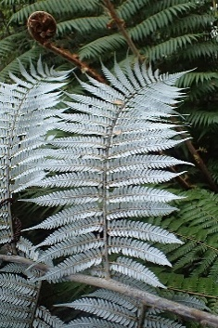
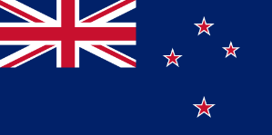
The flag of New Zealand has the Union Flag of the United Kingdom in the upper left quarter and the Southern Cross on a blue ground. New Zealand's national symbol, the silver fern emblem, appears on army insignia and sporting team uniforms.
PROGRAMME

Day 1: Thursday, 15 October
Kia ora, Welcome to Tāmaki Makaurau also known as Auckland.
Auckland is a sporting and cultural city situated on a narrow isthmus between the harbours of Waitemata and Manukau. Numerous volcanic cones such as Mount Eden and Rangitoto Island abound. The Auckland metropolitan area is New Zealand's largest with a population mix of European, Maori and Pacific Islanders making it the largest Polynesian city in the World.
Private group transfer from the Auckland International Airport to the SkyCity Hotel Auckland.
Overnight.

Day 2: Friday, 16 October
Full buffet breakfast.
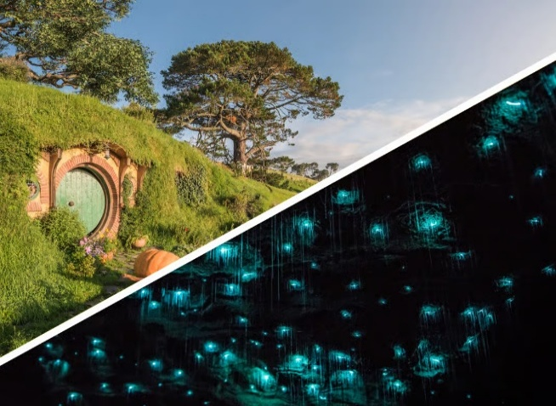
Departure to Rotorua visiting the Hobbiton Movie Set and Waitomo Gloworm Caves en route.
At the Hobbiton Movie Set experience the real Lord of the Rings in the heart of the Waikato region. A guide will point out the locations and explain how the movie magic was made. A complimentary Hobbiton ale, cider or ginger beer at the Green Dragon Inn.
In the Waitomo Gloworm Caves you will take a boat ride through the glowworm grotto marvelling at thousands of Arachnocampa luminosa, a glowworm species found only in New Zealand.
Includes a picnic lunch.
Overnight at Millennium Hotel Rotorua (Superior Room).

Day 3: Saturday, 17 October
Full buffet breakfast.
Explore Rotorua during the day at your own leissure.
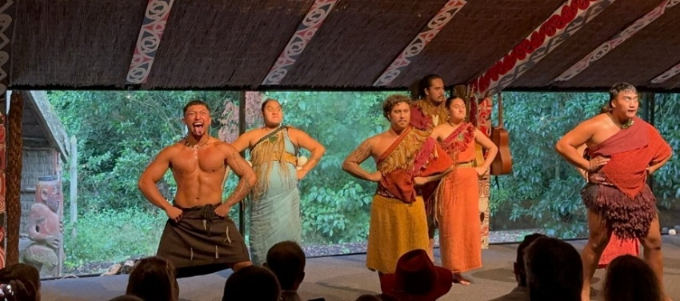
In the early evening your will be tranported to the Te Pā Tū Evening Māori Cultural Experience. Included. Immerse yourself among the towering Tawa trees and blazing bonfires. Learn about the history, culture and customs of the indigenous Māori. Delight your taste buds with a sumptuous 4-course Māori fusion feast. Folowed by a powerful cultural performance with storytelling and dance.
Overnight at Millennium Hotel Rotorua (Superior Room).

Day 4: Sunday, 18 October
Full buffet breakfast.
Your morning is at leissure.
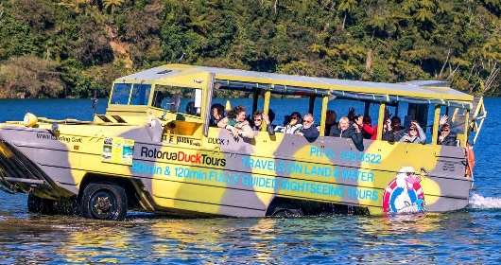
Early afternoon your will be picked up for the Rotorua Duck City and Lakes Tour which includes includes a tour through the city highlighting its amazing gardens, iconic buildings, and geothermal areas before heading out for Splashdown into two of Rotorua’s most stunning lakes.
Return to the hotel.

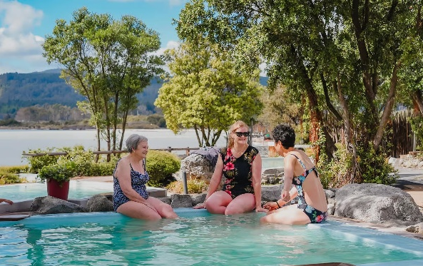
A visit to the Polynesian Deluxe Lake Spa which is located only 280 metres from the hotel will be ready to welcome to welcome at the end of tour.
Enjoy panoramic views of Lake Rotorua from 5 mineral pools set in native rock gardens.

Overnight at Millennium Hotel Rotorua (Superior Room).

Day 5: Monday, 19 October
Full buffet breakfast.
From the Intercity Coach Terminal in Rotorua departure by InterCity coach to the Sky City Bus Terminal in Auckland where the SkyDive bus has a regular service to the Auckland International Airport.

Package Details

Date: 15–19 October 2026.

Cost: USD 1,560.00 per person based on double occupancy. Single occupancy supplement USD 690.00.

Registration Deadline: 15 June 2026.

Registration Form: can be downloaded from the Events section of the WACA website www.waca.org or requested by e-mail from Mr. Keith Miller, WACA Administration Manager at wacaworld@outlook.com.

Payments: a deposit of USD 400.00 per participant is required to be confirmed on the package.
The deposit can be made by cheque, money order or bank draft in United States dollars made payable to the World Airlines Clubs Association and sent with the duly completed Registration Form to: World Airlines Clubs Association, c/o Mr Keith Miller, 644 Westwood Avenue, Dorval, Quebec, Canada H9P 2M5.

A deposit can also be made by bank transfer to WACA’s bank account as follows:
Bank of Montreal, 2005 Peel Street, Montreal, Quebec, Canada H3A 1T7.
Account name: World Airlines Clubs Association.
Account number: 4600-790.
Transit number: 01581-001.
Swift code: bofmcam2.
It is most important to note that bank transfer charges for both the issuing and receiving banks must be borne by the participant. WACA’s bank charges USD 16.00 for each transfer received.

The balance of payment can be made by one of the options above and must be sent by 14 August 2026 at the latest.

Regretfully, WACA does not have the capability to accept payments by credit card. Payment by PayPal is also not an option due to the high service charge incurred.

Note: deposits are subject to a USD 50.00 cancellation fee up to 1 June 2026. No deposit will be refunded after that date.

Package Includes
- One night’s accommodation based on double occupancy at the SkyCity Hotel Auckland and three night’s accommodation based on double occupancy at the Millennium Hotel Rotorua.
- Four breakfasts, one picnic lunch and one dinner.
- Three tours in air-conditioned coaches with English speaking guides.
- Group transfer from Auckland Airport to the SkyCity Hotel and from Rotorua to the Sky City Bus Terminal in Auckland.

Package Excludes
- Airfares.
- Personal expenses, e.g. laundry, telephone calls, Internet connection, etc.
- Meals, drinks, optional tours, etc. unless specified in the programme.
- WACA fee: USD 20.00 per participant.
- Gratuities for guides and drivers.
- Travel, cancellation and personal insurance. Please obtain emergency medical and trip cancellation insurance.
- Visa fee if applicable.
- Any other miscellaneous items as applicable.

Should you have any questions about the post-AGA tour, or require any further details, please send an e-mail to Keith Miller: wacaworld@outlook.com.

