57th ANNUAL GENERAL ASSEMBLY

Post-AGA (New Zealand North Island) Tour

15–19 October 2026

Hosted by
WORLD AIRLINES CLUBS ASSOCIATION

--------------------------------------------------------------------------------
--------------------------------------------------------------------------------

TENTATIVE PROGRAMME

Day 1: Thursday 15 October
Group transfers from the Auckland International Airport.
Transfer to SkyCity Hotel Auckland. Overnight.
Dinner.

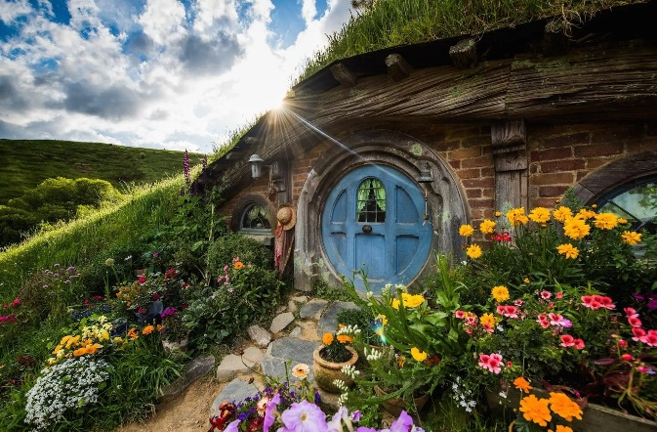
Day 2: Friday 16 October
Full buffet breakfast.
Waitomo Caves and Hobbiton Movie Set with Gray Line/Great Sights: includes picnic lunch.
Overnight at Millennium Hotel Rotorua (Superior Room).
Dinner.

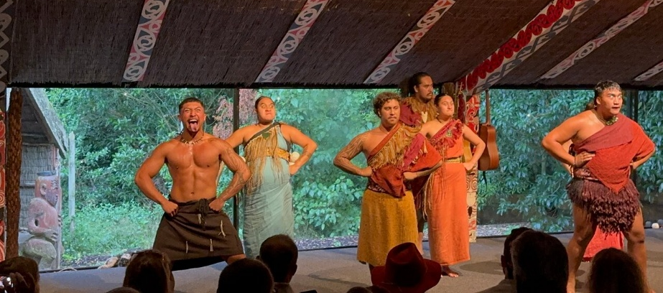
Day 3: Saturday 17 October
Full buffet breakfast.
Te Pā Tū Evening Māori Cultural Experience (dinner included).
Overnight at Millennium Hotel Rotorua (Superior Room).

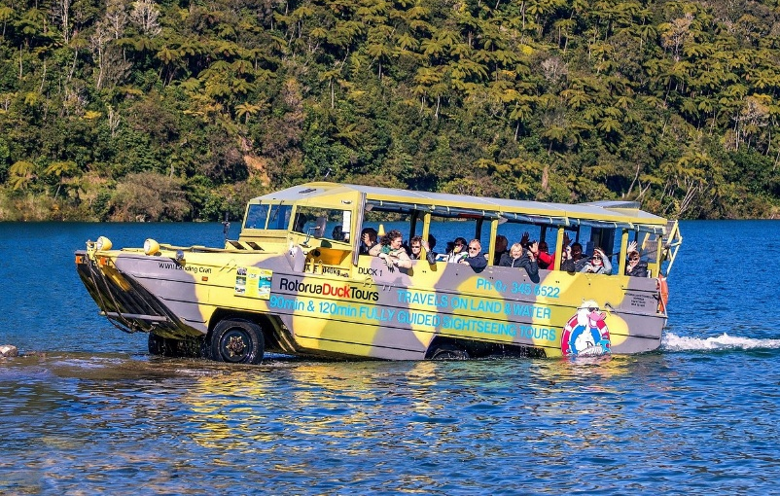

Day 4: Sunday 18 October
Full buffet breakfast.
Rotorua Duck Tours City and Lakes Tour: Polynesian Spa Deluxe Lake Spa.
Overnight at Millennium Hotel Rotorua (Superior Room).
Dinner.

Day 5: Monday 19 October
Full buffet breakfast.
Rotorua to Auckland by InterCity Coach.
Cost per person based on double occupancy NZD 2,350.00 (approximately USD 1,350.00) plus USD 20.00 WACA fee.
Single occupancy: NZD 2,675.00 (approximately USD 1,525.00) plus USD 20.00 WACA fee.
N.B. Payment for the tour will be in United States dollars and the exchange rate used above is subject to change.

Flights
We will receive a discount on Fiji Airways flights from any destination to/from the Fiji AGA and then to/from Auckland. This discount only applies on flights that are booked on the same reservation. The discount to be advised.

